1. Let

1. Find the eigenvalues of *A*.
2. Find one eigenvector corresponding to each eigenvalue.
3. Find matrices *P* and *D* such that *D* is diagonal and

**Solution**

1. Find the eigenvalues of the matrix. To do this, we find the values of *λ* which satisfy the characteristic equation of the matrix *A*, namely those values of λ for which

where *I* is the 2×2 identity matrix.

Form the matrix :

Notice that this matrix is just equal to *A* with *λ* subtracted from each entry on the main diagonal.

Calculate :

Therefore

Find solutions to i.e., to solve

For ﬁnding the roots of a quadratic equation of the form (with ) using Vieta’s formula:

Thus

Therefore, the eigenvalues of *A* are

**Answer:**

1. We can find the eigenvectors by Gaussian Elimination.

For each eigenvalue λ, we have

where *x* is the eigenvector associated with eigenvalue *λ.*

Find *x* by Gaussian elimination. That is, convert the augmented matrix

to row echelon form, and solve the resulting linear system by back substitution.

We find the eigenvectors associated with each of the eigenvalues.

Case 1:

We must find vectors *x* which satisfy.

First, form the matrix:

Construct the augmented matrix and convert it to row echelon form

Rewriting this augmented matrix as a linear equation gives:

So the eigenvector x is given by:

for any real number. Those are the eigenvectors of *A* associated with the eigenvalue .

Case 2:

We seek vectors *x* for which .

Form the matrix

Construct the augmented matrix and convert it to row echelon form

Rewriting this augmented matrix as a linear equation gives:

So the eigenvector x is given by:

for any real number . Those are the eigenvectors of *A* associated with the eigenvalue .

For example, if then the eigenvectors of *A* associated with the eigenvalue :

with the eigenvalue :

**Answer:**

1. In (b) we find two linearly independent eigenvectors of *A.* Construct matrix *P* from these vectors.

Let

Construct diagonal matrix *D* from the corresponding eigenvalues:

Let

We can double check if *P* and *D* really work:

**Answer:** ;

2. Two football teams, Richwood and Hawthendon are to meet in the grand final. Hawthendon prefers to play in fine weather, and, for a fine day, Pr[Hawthendon wins]=0.8. For a wet day, however, Pr[Richwood wins]=0.6. As it happens the probability that the day of the grand finale is wet is .

[Assume that is not possible for a grand final match to end in a draw.]

1. Find the probability that Hawthendon wins.
2. Use Bayes’ theorem to calculate the probability that the day of the grand finale is wet given that Richwood won.

**Solution**

1. Let ‘*A*′ represent the event of win of Hawthendon.

Let ‘*B*′ represent the event of win of Richwood

Let ‘*H*1′ represent the event of fine weather in day of the grand final.

Let ‘*H*2′ represent the event of wet weather in day of the grand final.

Then the probability that Hawthendon wins will be represented by the law of total probability as:

where is the probability that Hawthendon wins;

is the probability that in day of the grand finale is fine weather;

is the probability that in day of the grand finale is wet weather;

is the probability that Hawthendon wins given that in day of the grand final was fine weather;

is the probability that Hawthendon wins given that in day of the grand final was wet weather.

According to question:

As the weather can be only fine or wet then

We assume that is not possible for a grand final match to end in a draw. Then only two options are possible these are win of Hawthendon or Richwood. Thus is equal the probability that Richwood doesn’t win given that in day of the grand final was wet weather (). And according to question .

Therefore

On substituting we get

**Answer:**

1. At first we use Bayes’ theorem to calculate the probability that the day of the grand finale is wet given that Hawthendon won ():

As that is not possible for a grand final match to end in a draw, then the probability that the day of the grand finale is wet given that Richwood won ( is equal the probability that the day of the grand finale is wet given that Hawthendon didn’t win ().

Thus

**Answer:**

1. Let .
2. Find all of the stationary points of .
3. For each stationary point, classify it as a local minimum, local maximum or saddle point.

**Solution**

1. First we write down the partial derivatives of

Now we solve the equations and :

From (1) we obtain:

removing the common factor.

We obtain solutions:

Now substitute into (2):

i.e.

i.e.

Substitute into (2):

i.e.

i.e.

i.e.

The stationary points are

**Answer:**

1. We have from (a):

Find the second order derivatives of :

Substituting stationary point (0,0) into the expressions for , and gives:

Using the next formula find *D*:

As then stationary point (0,0) is a saddle point.

Substituting stationary point (2,0) into the expressions for , and gives:

Using the next formula find *D*:

As then stationary point (2,0) is a saddle point.

Substituting stationary point into the expressions for , and gives:

Using the next formula find *D*:

As and then stationary point is a local minimum.

**Answer**: The stationary points are saddle points and is a local minimum.

1. For a particular random experiment , , and
2. Copy and complete the following table. [ denotes the complement of and denotes the complement of B.]

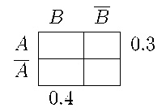

1. Are and independent? Justify your answer.

The random variable takes the value 4 if both and occur, 3 if occurs and not B, 2 if occurs and not , and 1 if neither nor occur.

(c) Specify the probability distribution of .

(d) Find the mean and variance of .

(e) Find the mean of .

**Solution**

1. Using the property of probability of complement find :

Then the table has to look so:

|  |  |  |  |
| --- | --- | --- | --- |
|  | *B* |  |  |
| *A* |  |  | 0.3 |
|  |  |  | 0.7 |
|  | 0.4 | 0.6 |  |

Using the Addition Law of Probability find :

i.e.

Let's substitute values of probabilities, then

Using the Law to Total Probability find :

i.e.

Let's substitute values of probabilities, then

i.e.

Let's substitute values of probabilities, then

Using De Morgan’s law (find :

Let's substitute value of probability, then

Complete the table

|  |  |  |  |
| --- | --- | --- | --- |
|  | ***B*** |  |  |
| ***A*** | **0.2** | **0.1** | **0.3** |
|  | **0.2** | **0.5** | **0.7** |
|  | **0.4** | **0.6** |  |

1. If and are not independent (mutually exclusive) then , i.e.

But according to question then ,

i.e. and are independent.

**Answer:**  and are independent.

1. Using (a) and placing value X on increase complete the table

|  |  |  |  |  |
| --- | --- | --- | --- | --- |
|  |  |  |  |  |
| **X** | **1** | **2** | **3** | **4** |
| **Pr(X)** | **0.5** | **0.2** | **0.1** | **0.2** |

The table specify the probability distribution of .

1. Find the mean of using the formula:

Let's substitute values of the table from question (c), then

Find the variance of using the formula:

then

**Answer:**

1. Complete the table for :

|  |  |  |  |  |
| --- | --- | --- | --- | --- |
|  |  |  |  |  |
|  | 1 |  |  |  |
| Pr(X) | 0.5 | 0.2 | 0.1 | 0.2 |

Using the formula (*) and the table find the mean of :

i.e.

**Answer:**

1. A continuous random variable Y takes values in the interval [0, 2] and has probability density function on that interval, where c is some real number.
2. Find the value of *c*.
3. What is ?

**Solution**

1. If the function is the probability density of the absolutely continuous random variable *Y* then it must satisfy

As function is probability density we must have

Find

Let's substitute value of the integral in (**)

i.e.

**Answer:**

1. As then

Using the formula:

Find

And according to question Y takes values in the interval [0, 2], then

**Answer:**

1. Each part (a)-(e) of this question relates to the graph shown below. The vertices are the circles labelled with capital letters and the edges are straight lines. Do not confuse the five ‘crossings’ in the middle of the graph with vertices.

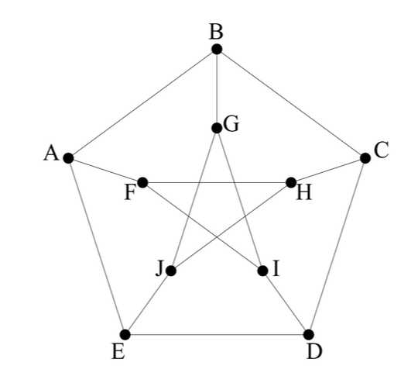

Graph 1.

1. The number of edges in this graph is . Explain each of the numbers in this

expression and why it is true.

To answer parts (b)-(d) please describe each path or trail by giving its vertex sequence. ‘AFID’, for example, describes a path of length 3.

1. Find a trail of length 11, beginning at vertex A. [A trail may visit any vertex more than once but never uses an edge more than once.]
2. Find circuits in this graph, each beginning at vertex A, of lengths 5, 6, 8 and 9.

[A circuit must finish where it starts and never visits other vertices more than once.]

1. Find a path beginning at vertex A which visits every vertex. [A path never visits a vertex more than once. This path need not be a circuit.]
2. What is the maximum number of edges that can be removed from this graph without disconnecting it. Fully explain your answer.

**Solution**

1. The number of edges in this graph is ,

where number 10 is quantity of vertices in this graph; number 3 is quantity of edges which leave each vertices in this graph, then total of edges is equal . But as each edge connects two vertices, the received quantity of vertices needs to be divided on 2.

1. The options of the trails of length 11 are ‘ABCDEAFHJGIF’, ‘ABCDEAFIGJHF’.
2. The options of the circuit in this graph of lengths

5: ‘ABCDEA’, ‘ABCHFA’, ‘ABGIFA’, ‘AEJHFA’, ‘AEDIFA’, ‘AFIDEA’, ‘AFHCBA’;

6:’ABCDIFA’, ‘AFHCDEA’, ‘AEDCHFA’, ‘AFIDCBA’;

8: ‘ABCDIGJEA’, ‘ABCHFIDEA’, ‘AEDCHJGBA’, ‘AEDIFHCBA’, ‘ABCDEJHFA’, ‘AEDCBGIFA;

9: ‘ABCDEJGIFA’.

1. The options of the paths beginning at vertex A which visits every vertex:

‘ABCDEJHFIG’, ‘ABCDEJGIFH’.

1. The maximum number of edges is 6 that can be removed from this graph without disconnecting it. There are examples of such graphs below (Graph 2,3)

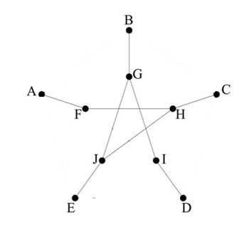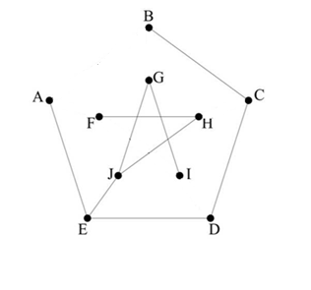

Graph 2 Graph3

If to remove at least one edge that the graphs will become disconnected. There are examples of such graphs below (Graph 4,5):

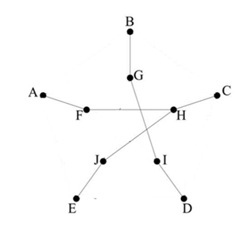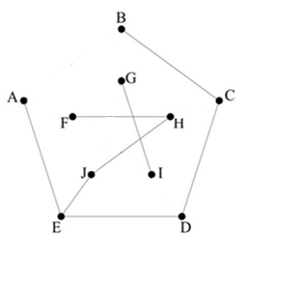

Graph 4 Graph 5

On 4 we took away edge JG received 2 connected graphs with vertices: {A,F,H,C,J,E} and {B,G,I,D}.

**Answer:** the maximum number of edges is 6.

1. A book is being prepared for publication. Each page has height *y* cm, width *x* cm and a fixed total area of 294 cm2. Each page has a 3 cm margin at both the top and bottom and a 2 cm margin on each side. Let *A* be the area of that part of the page which is available for printing.
2. If A is expressed solely in terms of x show .
3. What restrictions are there on the values of x?
4. Find the dimensions of a page which will provide maximum space for printing.

**Solution**

1. According to the question each page has height *y* cm, width *x* cm and a fixed total area of 294 cm2. Using the formula for area of rectangle get:

then

As each page has a 3 cm margin at both the top and bottom and a 2 cm margin on each side, then that part of the page which is available for printing has next dimensions: height cm, width cm. And the area of that part of the page which is available for printing is

Let's substitute expression of *y* through *x*:

Thus simplifying we receive

1. As each page has 2 cm margin on each side, then width cannot be less than cm.

As each page has a 3 cm margin at both the top and bottom then height y of page cannot be less than cm. Thus width cannot be more than

Answer: .

1. Calculate the derivative of the area function, and set it equal to zero.

We are interested only in positive value *x.*

As for , and for then maximum point and the rectangle have largest area for it (150).

The height of part of the page for printing is ; the width is .

**Answer:** The height of part of the page for printing is ; the width is .

8. Doris Daley’s car dealership (Daley Motors) sells vans and sedans. The vans have 4 optional extras, each of which can either be selected or not. The sedans have 6 optional extras but a buyer cannot select more than 3 of them. In addition to the optional extras, every vehicle is available in 4 different colors. Doris doesn’t sell any of the vehicles herself but leaves that task to her two sales assistants Justine and Terri. Justine deals exclusively with vans, while Terri deals exclusively with sedans.

1. How many different vehicles can be purchased with Justine as the salesperson?
2. How many different vehicles can be purchased with Terri as the salesperson?
3. A company buys a fleet of 4 vehicles from Daley Motors. How many different fleets are possible?
4. How many of the fleets in part (d) include at least 1 van?

You may leave your answers to (c) and (d) as expressions, but your answers to (a) and (b) should be explicit numbers.

**Solution**

1. According to the question: Justine deals exclusively with vans. The vans have 4 optional extras, each of which can either be selected or not and every vehicle is available in 4 different colors. Then the possibilities are:

vehicle has 1 optional extra from 4 and is available in 4 different colors

or vehicle has 2 optional extras from 4 and is available in 4 different colors,

or vehicle has 3 optional extras from 4 and is available in 4 different colors,

or vehicle has 4 optional extras from 4 and is available in 4 different colors.

Therefore, using the rule of the sum and multiplication the possible number of different vehicles is

**Answer:** 60vehicles can be purchased with Justine as the salesperson.

1. According to the question: Terri deals exclusively with sedans. The sedans have 6 optional extras but a buyer cannot select more than 3 of them and every vehicle is available in 4 different colors. Then the possibilities are:

vehicle has 1 optional extra from 6 and is available in 4 different colors

or vehicle has 2 optional extras from 6 and is available in 4 different colors,

or vehicle has 3 optional extras from 6 and is available in 4 different colors.

Therefore, using the rule of the sum and multiplication the possible number of different vehicles is

**Answer:** 164vehicles can be purchased with Terri as the salesperson.

1. From (a) and (b) we can know the total of options of vehicles from Daley Motors is 60+164=224.

In a task it is not told that vehicles of the fleet have to be different. Then the first, the second, the third and the fourth vehicles of the fleet are available in 224 different cars.

Therefore, using the rule of the multiplication the possible number of different fleets is

**Answer:**  is the possible number of different fleets.

1. According to the question: the fleets in part (d) include at least 1 van. Then the fleets can include 1 van, 2 vans, 3 vans or 4 vans. Then the possibilities are:

fleet has 1 van and 3 sedans,

or fleet has 2 vans and 2 sedans,

or fleet has 3 vans and 1 sedan,

or fleet has 4 vans.

From (a), (b) differentvans are 60 types and sedans are 164 types. Therefore, using the rule of the sum and multiplication the possible number of different fleets is

**Answer:**  is the possible number of different fleets.